# Homework: Databases

Problems for homework for the **"Software Technologies" course @ Software University**  
Submit this document as your homework

## Address Table

**You will create a table named 'addresses', insert data, and run a few queries on** [**https://db-fiddle.com**](https://db-fiddle.com)**.**

**Choose MySQL 8.0 as the engine.**

1. **CREATE TABLE** named `**addresses**` with the following columns:
   * **street_number**
   * **street_name**
   * **area**
   * **town**
   * **district**
   * **country**
   * **continent**
   * **isCapital**

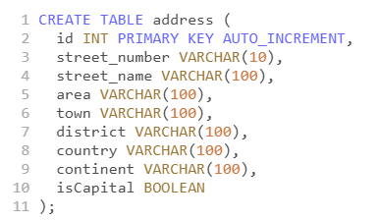

1. **INSERT** records **INTO** the '**addresses**' table and execute the SQL query:

INSERT INTO address (street_number, street_name, area, town, district, country, continent, isCapital)

VALUES

('10', 'Main Street', 'Downtown', 'New York City', 'Manhattan', 'United States', 'North America', false),

('25A', 'Elm Avenue', 'West End', 'London', 'Westminster', 'United Kingdom', 'Europe', true),

('7', 'Rue de la Paix', 'Le Marais', 'Paris', 'Ile-de-France', 'France', 'Europe', true),

('1234', 'Oak Lane', 'Green Meadows', 'Los Angeles', 'California', 'United States', 'North America', false),

('42', 'High Street', 'City Center', 'Sydney', 'New South Wales', 'Australia', 'Australia & Oceania', false),

('56B', 'Maple Road', 'Northside', 'Toronto', 'Ontario', 'Canada', 'North America', false),

('9', 'Kaiserstrasse', 'Mitte', 'Berlin', 'Berlin', 'Germany', 'Europe', true),

('17', 'Plaza Mayor', 'Centro', 'Madrid', 'Madrid', 'Spain', 'Europe', true),

('3', 'Piazza San Marco', 'San Marco', 'Venice', 'Veneto', 'Italy', 'Europe', false),

('1001', 'Avenida Paulista', 'Jardins', 'Sao Paulo', 'Sao Paulo', 'Brazil', 'South America', false),

('8/15', 'Princes Street', 'New Town', 'Edinburgh', 'Edinburgh', 'United Kingdom', 'Europe', false),

('27', 'Koningsplein', 'Centrum', 'Amsterdam', 'North Holland', 'Netherlands', 'Europe', true),

('42A', 'Hauptstrasse', 'Mitte', 'Vienna', 'Vienna', 'Austria', 'Europe', true),

('100', 'Collins Street', 'CBD', 'Melbourne', 'Victoria', 'Australia', 'Oceania', false),

('123', 'Rua da Boavista', 'Baixa', 'Porto', 'Porto', 'Portugal', 'Europe', false),

('5', 'Knez Mihailova', 'Stari Grad', 'Belgrade', 'Belgrade', 'Serbia', 'Europe', true),

('9876', 'Ginza', 'Chuo', 'Tokyo', 'Tokyo', 'Japan', 'Asia', true),

('18', 'Connell Street', 'North City', 'Dublin', 'Dublin', 'Ireland', 'Europe', true),

('75C', 'Friedrichstrasse', 'Kreuzberg', 'Berlin', 'Berlin', 'Germany', 'Europe', true),

('22', 'Gran Vía', 'Malasana', 'Madrid', 'Madrid', 'Spain', 'Europe', true);

1. **Your task is to execute the proper queries in order to get the following results:**

* **NOTE: Create queries for each condition and place a screenshot after each query!**
  + SELECT all addresses from the 'addresses' table that are located in a capital city.

**Your screenshot here…**

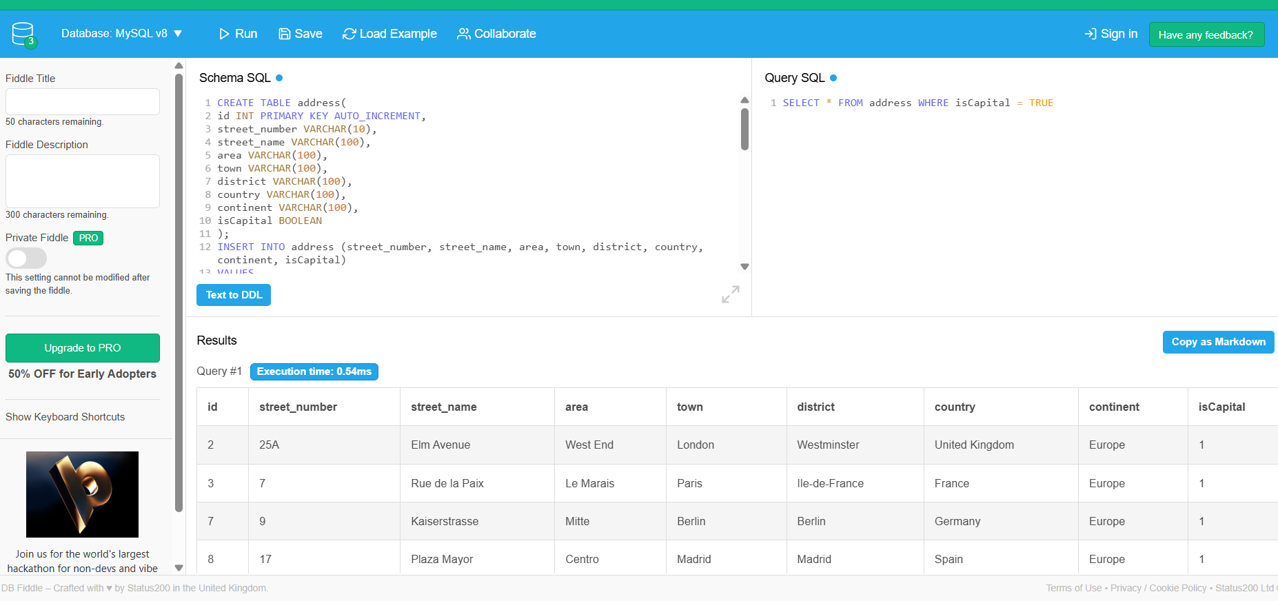

* + SELECT all addresses from the 'addresses' table that are located in South America.

**Your screenshot here…**

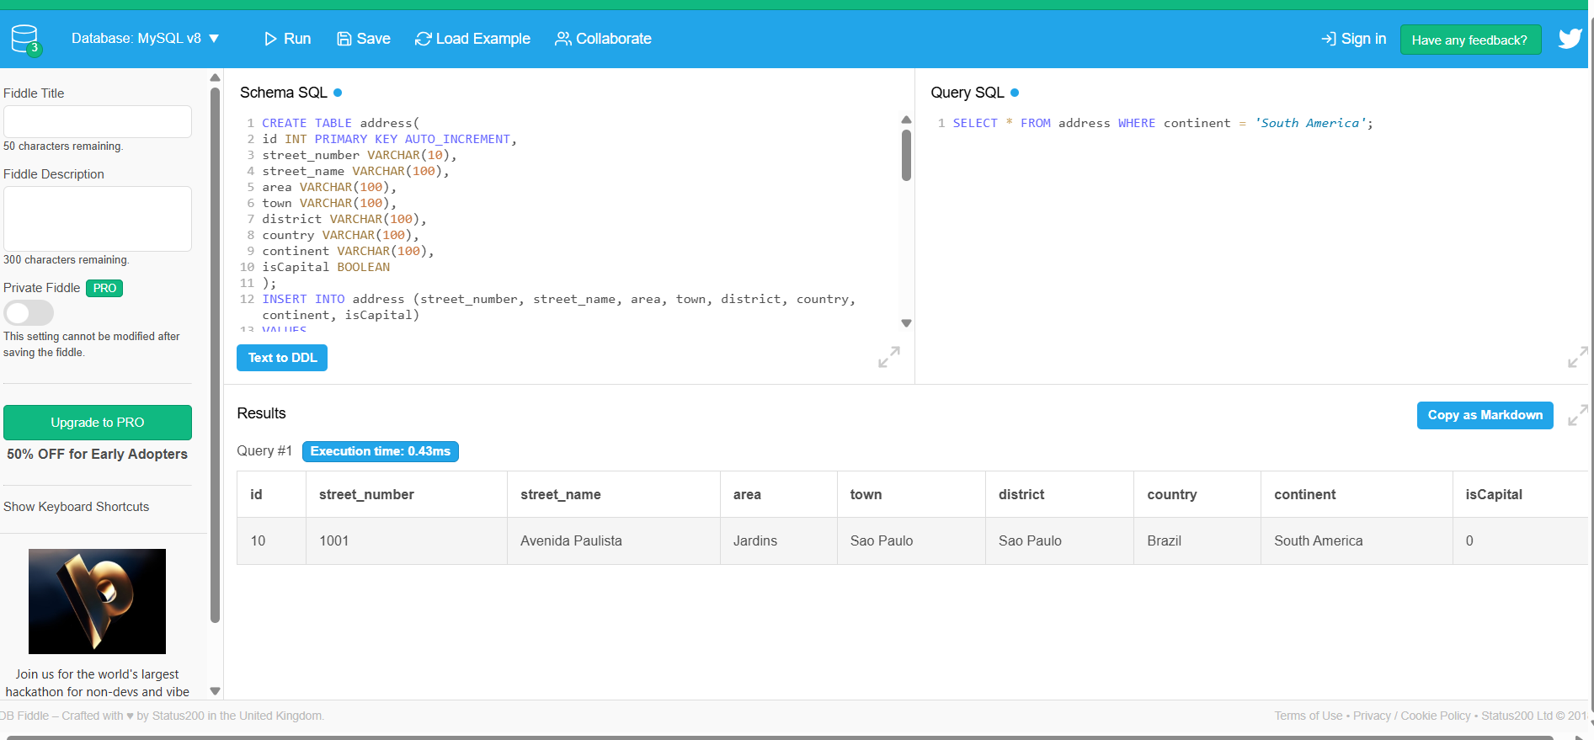

* + SELECT all addresses from the 'addresses' table that are located in Europe,   
    but only in NON Capital cities.

**Your screenshot here…**

